Superior Tank Solutions Water Storage Tank
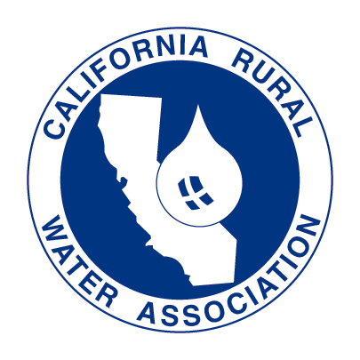
Design & Maintenance
January 21, 2014
Oakley (Contra Costa County)
Classes Presented by Superior Tank Solutions in cooperation with California Rural Water Association

Registration: 8:15 am – 8:30 am
Classroom Session: 8:30 am – 3:30 pm
Lunch: 12:00 – 1:00 pm (provided by Superior Tank Solutions)
The intent of this session is to provide an all-encompassing view of water storage tanks, beginning with storage tank fundamentals and progressing through the proper methods to achieve 100+ years of continued tank serviceability. The session will include detailed photographic and narrative documentation presented through Power Point presentations, small group activities, and handouts to assist with ongoing tank maintenance. Attendees will learn the advantages and disadvantages of the different tank types, proper storage tank maintenance and the synergistic relationship between tank management and water quality. Information will be discussed at a basic level and progress through the more complex tank issues of current regulatory standards, old and new coating systems, inspections, biofilm, stratification, mixing, and lifecycle cost analysis. The following course criterion will be incrementally.

- Tank Selection and Design Process
- Tank Inspection Protocol
- Tank Maintenance Protocol
- Tank’s Impact on Water Quality

Contact Hours: 6 CDPH Water Contact Hours

Locations: Randall-Bold Water Treatment Plant, 3760 Neroly Road, Oakley, CA 94561

January 21, 2014: Contra Costa (Contra Costa County)
Instructor:
Matt Tasch, Superior Tanks, holds a B.A. Degree from Arizona State University and is a certified distribution operator in Arizona. He is an owner and Director at Superior Tank Solutions, Inc. where he is currently employed as the Director of Project Management. He has over 10 years of consulting and project management experience in water distribution with a focus on corrosion control, maintenance, and water quality with an emphasis on steel tanks. He is certified as a Competent Person in lead abatement, fall protection, and confined space. Mr. Tasch currently serves on the AWWA Distribution O and M Committee and as outgoing chair for the Arizona Water Distribution Committee. He has been approved to provide training for Contact Hours in 4 states.

John E. Hake, Superior Tanks, holds a B.S. Degree from the Pennsylvania State University and is an ASTM D.4537 Certified Level III Nuclear Coatings Inspector. He currently provides over 100 hours of certified training annually and has served as Chair of the AWWA California-Nevada Section Operations and Maintenance Technical Committee, Chairman for the Society of Protective Coatings – Southern California Chapter, National Association of Corrosion Engineers – L.A. Chapter and the Western States Corrosion Seminar. He has presented numerous technical papers for California Rural Water, AWWA, NACE, and SSPC on potable water tank design, construction, and maintenance. Mr. Hake is currently employed as the Technical Service Manager for Superior Tank Solutions, Inc.

Information for the Attendee:
- A confirmation letter and map will be sent to you within two weeks of the class date.
- All registrants who have registered and paid for class at least seven business days prior to class will receive their certificate on-site.
- If any registrant requires special accommodations for disabilities, please contact our office at 800-833-0322 ext 1.
- Cancellations must be received by CRWA in writing five business days prior to the event to qualify for a refund.
- Cancellations received within this time frame, will be subject to a full refund less a $25 processing fee.
- All class transfer requests must be received 5 business days prior to class and are subject to CRWA approval. Transfers will only be valid within the same calendar year.

Registration Form CRWA MEMBERS: $125 per day NON-MEMBERS: $175 per day

Location: January 21, 2014: Oakley (Contra Costa County

Attendee(s) Name(s):
System or Company Name:
System or Company Address:
City: State: Zip:
Phone: FAX: Email:
CRWA Member ($125 per day) Non-Member ($175 per day) Payment Total: $

Check to follow in mail (payable to CRWA) Credit Card (print info below)

Credit Card #: Expiration Date:

Authorized Signature:

TO REGISTER: Please fax this form to 916-553-4904

or email to mcochran@calruralwater.org

or mail to CRWA, 4131 Northgate Blvd, Sacramento, CA 95834.

Opt-out: If you wish to be taken off our distribution list, please call 800.833.0322 or email ccolson@calruralwater.org. Thank you!

